107 Warren St. | Blacksburg, VA, 24060 | 540-473-4302

Kevin Price  
Chair, Blacksburg Environmental Committee  
Blacksburg Town Hall  
87 Draper Ave  
Blacksburg, VA 24060

Dear Mr. Price:

In reply to the RFP for a proposal on an initiative to drive focus to eliminate the carbon footprint in the Blacksburg area while being green and cost-effective. With over thirty-thousand students in the area and attending Virginia Tech, GreenTeam proposes implementing several compost areas on campus that includes helping eliminate food waste on the Virginia Tech campus, show how to create positive change for the environment in the New River Valley.

The initiative is to provide students and faculty at Virginia Tech an opportunity to help promote change to increase environmental sustainability awareness while being cost-effective and environmental friendly. Future students and faculty members should have the opportunity to create impact for the Blacksburg environment.

The GreenTeam proposes building on-campus and off-campus composting sites that are accessible for residents of the area. To promote efforts the GreenTeam can offer incentives through social media giveaways and discounts for local businesses. A prominent piece to help GreenTeam be successful is campus involvement. With help from the university, we build on-campus composting locations, create competitions with student body organizations, and to incorporate hands-on involvement from students in the agriculture curriculum.

The attached proposal details our design of the composting sites, which includes a proposed strategy to advance composting involvement, a proposed itemized budget, and a timetable of steps to organize the workshop.

Any questions or concerns can be discussed by contacting us over the phone at (540)-473-4302. Thank you for your consideration of our proposal and we look forward to hearing from you shortly.

Sincerely,

*Marhawe Asmerom*

Dr. Marhawe Asmerom, Lead Biologist

GreenTeam

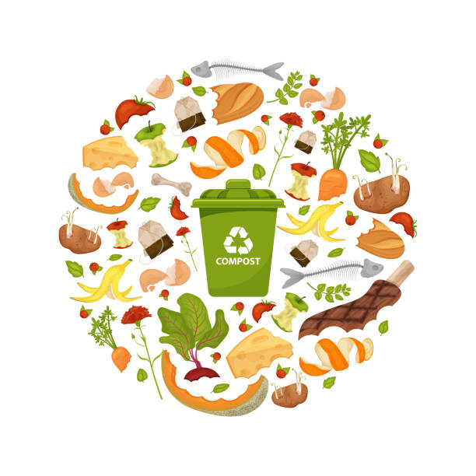

Figure 1[1]

**Submitted from**

Dr. Marhawe Asmerom  
GreenTeam

1 April 2022

1

**Submitted to**

Kevin Price  
Chair, Blacksburg Environmental Committee  
Blacksburg Town Hall  
87 Draper Ave  
Blacksburg, VA 24060

Table of Contents

Introduction 4

Statement of the Problem 4

Proposed Solution 5

Qualifications 6

Budget 7

Conclusion 8

# Introduction

The purpose of this proposal is to promote environment change for Blacksburg Community while being cost-effective and environmental friendly. These changes would allow students and teachers to participate in an opportunity that helps cancel food waste on campus, which could lead to effectively saving water, eliminating the carbon footprint in the NRV area, and conserve landfill space for the future student and faculty members.

This proposal suggests to find locations on campus that are convenient for students and faculties to compost excess food waste that is not thrown away on campus dining halls. Throughout the proposal it gives a framework to find effective location for compost, compile an estimated budget, and suggest a timeline to facilitate the project.

# Statement of the Problem

There is an emphasis on the Earth is our home and we must provide care for long-term sustainability. It is simple, we must do our job to conserve the natural resources given from the environment including water, clean air space, and energy. Since environmental education is not promoted, there is lack of understandings that leaving your lights overnight, excess water use, and food waste can cause long-term damage to the overall health of the environment.

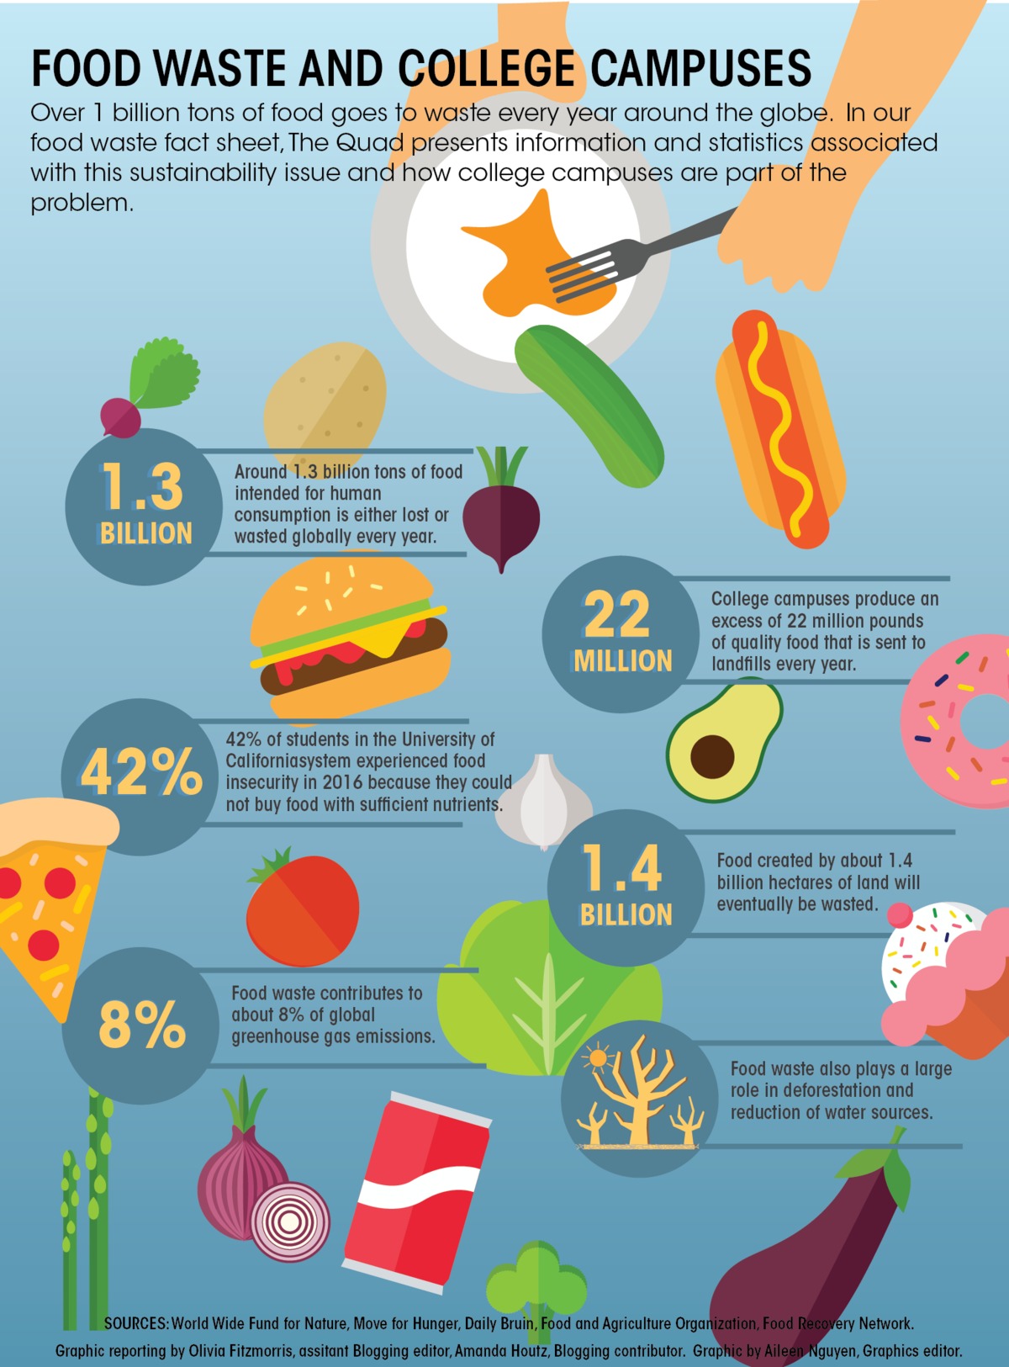Food waste is the one of the leading factors to environmental damage and a loss of sustainability in the area. College students are the leading candidates for contributing the most overall food waste with near a billion pounds of food waste yearly (Figure 1). [2] The lack of areas for students and faculty members to compost their excess of food waste. In a comprehensive waste management report given from the university it shows that “five hundred sixty-six tons of food waste is compiled from the eleven dining halls but only ten percent of the waste is recycled.”[3] This number could be worse at smaller universities and needs to be currently improved at Virginia Tech.

The lack of accessible composting areas give students no opportunity to manage and compost their food waste. Composting is not common theme in secondary education curriculum and the benefits for composting are overlooked.

Figure 1 : College Student Food Waste Statistics

The lack of campus and off-campus areas to compost food is not indicative of all cases for lack of composting. By educating and creating composting spots, we can create a positive change for the Blacksburg environment in the long-term to eliminate the carbon footprint.

# Proposed Solution

The overall goal is to provide economic sustainability within in the Blacksburg area and around the Virginia Tech campus. TheGreenTeam recommends creating compost areas throughout campus hotspots to help combat the excess food waste from students and faculty members. This could be a great opportunity for environmental students to gain volunteer hours, and Virginia Tech help the surrounding communities.

To create engagement to help Blacksburg reduce greenhouse emissions it is important to present interactive, accessible, and engaging ways to residents of Blacksburg. These activities will bolster the ongoing efforts to provide accessible compost food waste. It is important to note that these promotions can be openly discussed openly after the approval of this proposal.

***Accessible Composting Spots***

To better engage the residents of the Blacksburg area in composting efforts; accessibility is key.

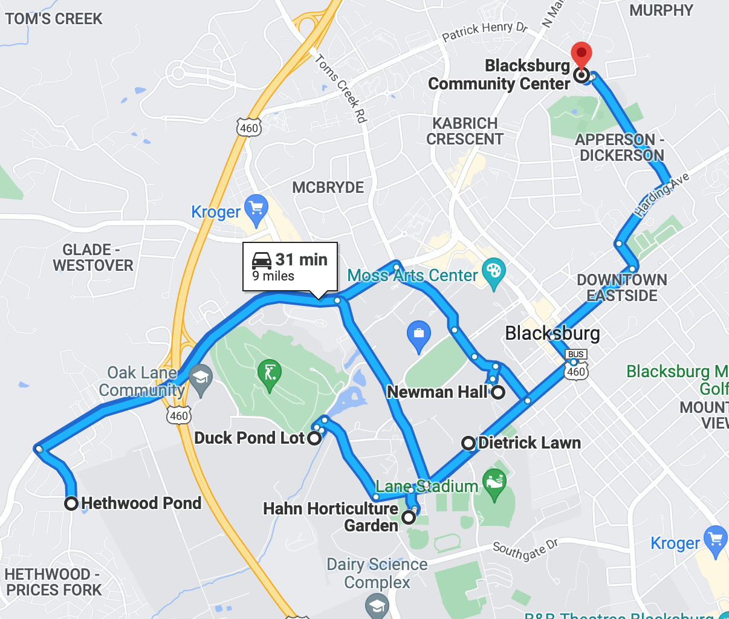It is important to find high volume spots on-campus with factors that include enough space, foot traffic, and relativity close to dining areas. For the Blacksburg, it would be smart to have six composting areas with two being off-campus. Our initial idea, is to split the six spots evenly into major and minor composting spots. The major spots have adequately more space with larger composting tumblers. Minor spots have smaller space and less materials at site but greater accessibility with composting bins. The major areas on campus are intended to be the Duck Pond, Hahn Horticulture Garden, and Hethwood Park. Minor composting areas include President Quad near Newman Hall, Town of Blacksburg Community Center, and Dietrick Lawn (Figure 3)[4]. These six spots can be change on further analysis and review of different factors.

Figure 2: Six Composting Location with a 30-minute radius

***Incentives***

The best way to promote a movement to bolster composting efforts is through incentives. Incentives in different avenues like partnership with local businesses, and giveaways on social media. The GreenTeam would work with popular food location as Sharkey’s, DP Dough, PK’s Grill, and others to offer coupons when someone visits one of the composting locations. All local businesses that we partner with will become official GreenTeam alliance’s. This agreement would be beneficial on both sides because it would stimulate business for the local restaurants and increase awareness for composting locally. Social Media is an amazing way to grasp an audience, it is important that we have strong present on various platforms. Many property managements groups including the *Hub of Blacksburg* and *Union* have grown awareness through social media giveaways. The GreenTeam can do monthly giveaways raffles on Instagram with items like iPads, Smart TV, or online gift cards. There would be requirements to enter the giveaways for example users would post a picture of themselves composting while tagging the GreenTeam social media page. Incentives are a great way to create engagement locally and help sustainability in the area.

***University Involvement***

With nearly thirty-seven thousand students on campus and a large majority of Blacksburg, it is imperative to get university involvement. Virginia Tech is a major key in the plan for composting first in allowing to usage of the on-campus spots and second with helping the student body get involved. A niche of students that could help facility this growth in composting is fraternity and sorority life. There are five thousand students making up twenty percent of the undergraduate body here at Virginia Tech[5]. Competitions between the fifty-two different chapters in who can compost the most food waste which can result in additional funding to the winning chapters philanthropic cause. Another avenue is academic involvement with the university. Our team would present the idea of composting to the College of Agriculture and Life Sciences to help update the efforts into the curriculum. It is important to let the students in the department have outdoor engagement and earn credit in class for participating at the composting sites. Students could have booths on campus where they hand out merchandise, teach students what can be composted, and spread awareness to the benefits of composting locally.

In sum, our proposal establishes a variety of ways to bolster composting efforts in Blacksburg area through accessibility, incentives, and student involvement.

# Qualifications

The GreenTeam has nearly twenty years of experience with transforming areas to be environmental sustainable by creating composting spots.

One of the lead biologist, Dr. Marhawe Asmerom, with fifteen years of experience is a Virginia Tech graduate who majored in environmental studies. As a graduate student seeking a PhD, his focus of study was nonrenewable resources, gas emission, and impacts of highly populated areas on the environment. Dr. Asmerom ability work in team environment, communicate, and strong dedication to his work paired with his extensive knowledge in the subject makes him a great candidate to lead the project.

A new member of the team that is eager to get started is Rachel Thomas, a data scientist with 10 years of experience. Her previous experience at Google Inc. working with Google Maps team for five years before deciding she wanted to try the environmental niche of work. In 3 years at Apeel Sciences, she became the leading data engineer that worked on creating plant-sealants to help eliminate food waste in the supply chain for grocery stores. Recently joining the GreenTeam, she will be tasked with analysis of foot traffic in the area to find hotspots to determine location for the best composting areas.

# Budget

The following is a proposed budget for initiative to create sustainability in the Blacksburg. The budget includes the scope of resources to develop composting spots for residents in the New River Valley mainly for the Blacksburg area. The table shows the project cost per unit and gives the GreenTeam a decent estimation of the total cost. Items listed can have various purposes including composting materials, promotion and incentives, and educational resources.

|  |  |  |
| --- | --- | --- |
| Item | Projected Cost (Per Item) | Purpose |
| Outdoor Compost Bins (Smaller Locations) 175 Gal. | $170.00[6] | Composting |
| Composter Tumbler (Larger Locations) 267 Gal. | $299.006 | Composting |
| Manure (60 lbs.) | $55.986 | Composting |
| Wire (10 lbs.) | $3.986 | Composting |
| Tools (Gardening Shears, Hammer, Wire Cutters) | $70.006 | Composting |
| Food Waste | $0.00 | Composting |
| Social Media Giveaways (Ex: AppleTV) | $199.99 | Incentives |
| Local Business Partnership | N/A (Updated after proposed) | Incentives |
| First Place for Student Life | $500 | University involvement |
| Second Place for Student Life | $250 | University involvement |
| Third Place for Student Life Competition | $100 | University involvement |
| Public Venue | $0.00 | University involvement |
| Booth Material (Water Bottles) | $5.90[7] | University involvement |
| Booth Materials (T-Shirts) | $8.78[8] | University involvement |
| Volunteer Labor (Students) | $0.00 | University Involvement |

# Proposed Timetable

The following timetable is anticipated: 6 months of time

|  |  |
| --- | --- |
| Task | Timetable |
| Begin Talks with University Student Life | 1 week from project approval |
| Begin Talks with Town of Blacksburg | 1 week from project approval |
| Begin Talks with Local Business Partners | 3 weeks from project approval |
| Find the Correct Spots to Begin Compost Setup | 6 weeks from project approval |
| Start Setup of Composting Sites | 8 weeks from project approval |
| Set up Social Media Accounts | 14 weeks from project approval |
| Find Volunteers and Train for Composting Sites | 18 weeks from project approval |
| Order Booth Materials (Merchandise, Build Awareness) | 20 weeks from project approval |
| Unveiling of Composting Spots | 24 weeks from project approval |

# Conclusion

We recommend the beginning of installation for composting sites in the Blacksburg area to start movements to help eliminate the carbon footprint acceding to the above proposal. Adjustments can be made to the proposed timetable and budget above per the Town of Blacksburg and Virginia Tech agenda. Our composting efforts allows accessible opportunity to compost food waste and retrieve incentives for helping the environment. This will offer all residents the chance to learn about composting while bring a positive influence to community.

Thank you for your consideration of our proposal. We can be reached by phone at (540)-473-4302 with any questions of concerns the may arise.

1. Composting Benefits. Digital Image. <http://istockphoto.com/organic-waste>. Web. 04 April 2022
2. College Student Food Waste. Digital Image. *dailybruin.com*. Web. 06 April 2022
3. Virginia Tech. 7 January 2021. *vt.edu.* 05 April 2022. < https://www.facilities.vt.edu/content/facilities_vt_edu/sustainability/waste-management-plans/ >
4. Composting Locations. Digital Image. <https://www.google.com/maps>. Web. 05 April 2022
5. Virginia Tech Fraternity and Sorority Life. 01 August 2021. *vt.edu*. 05 April 2022. < <https://fsl.vt.edu> >
6. Homedepot.com
7. Customink.com
8. Vistaprint.com